**5 volt to 90 volt boost supply build instructions**

Gather the tools and consumables:

* Wire cutters/strippers
* 3/64th inch heat shrink tubing
* Soldering iron and solder
* Heat gun

Buy the parts:

* 2 wire cable
* 5V to 12V boost converter
* 12V to variable high voltage boost converter

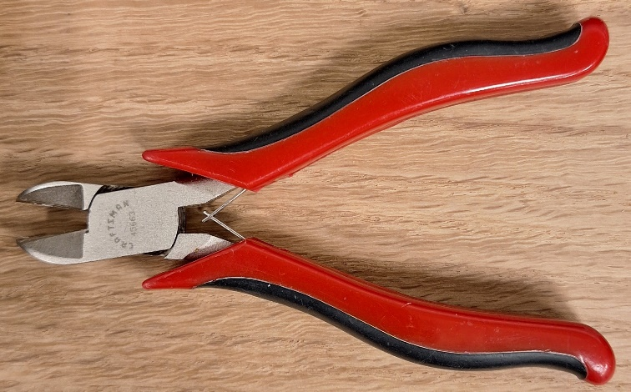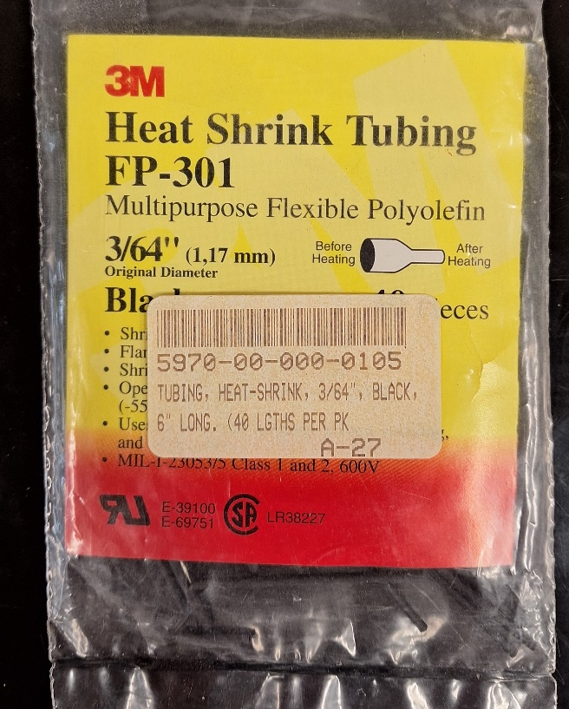

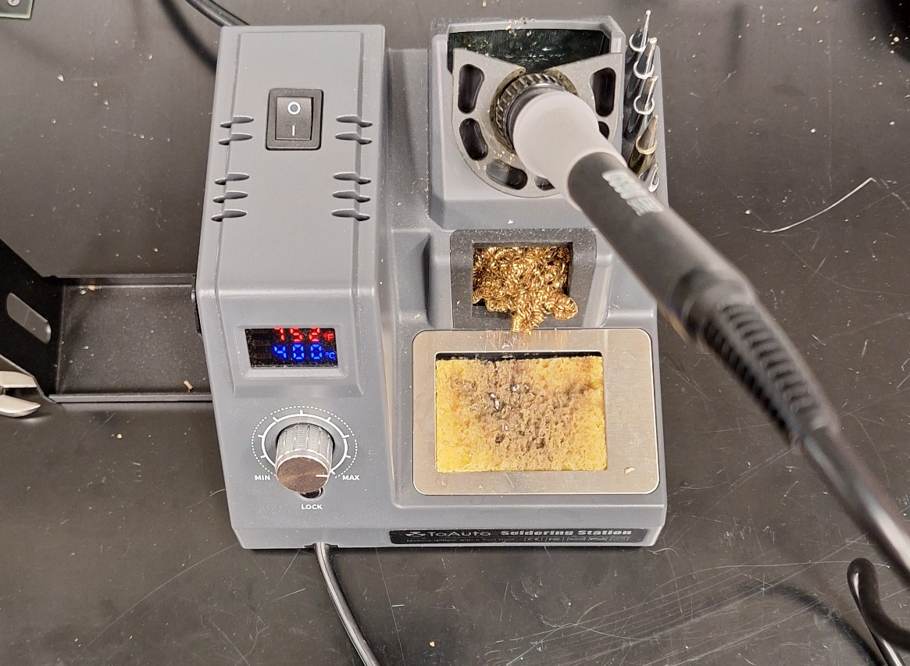

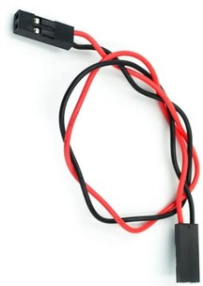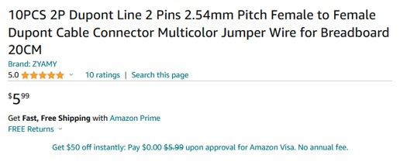

<https://www.amazon.com/ZYAMY-Dupont-Connector-Multicolor-Breadboard/dp/B0B8Z23NWX/>

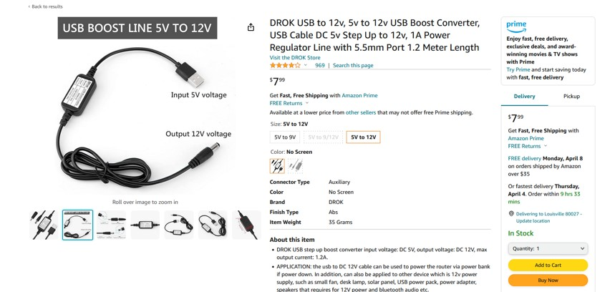

[https://www.amazon.com/DROK-Boost-Converter-Regulator-Length/dp/B09M3LMSS3/](http://localhost/MEMSduino/(https://www.amazon.com/DROK-Boost-Converter-Regulator-Length/dp/B09M3LMSS3/)

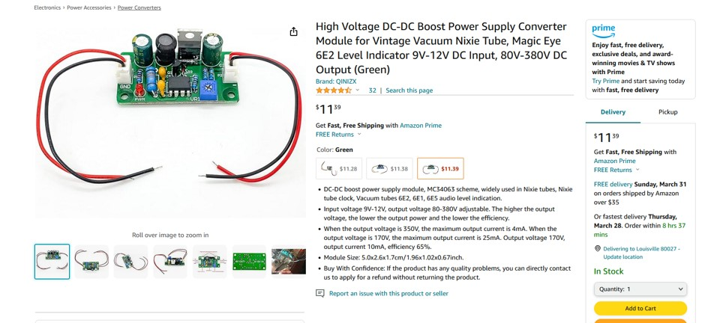

<https://www.amazon.com/Voltage-Converter-Vintage-Indicator-80V-380V/dp/B09D93QNYK>

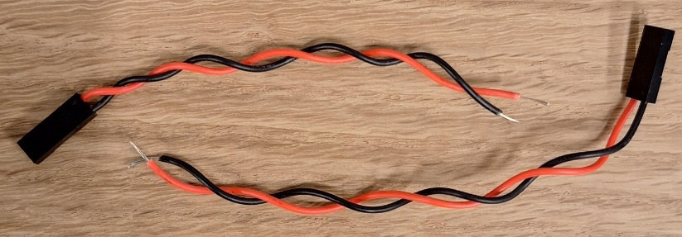

Cut the 2 wire cable in the middle and strip the ends, twist the strands so there no stray strands.

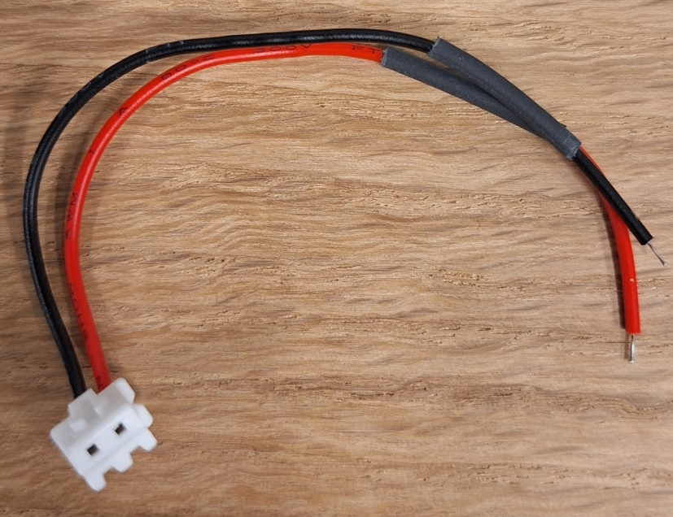

Put about 1/5 to ¾ of an inch of heath shrink tubing over the cable which goes to the high voltage output of the high voltage boost board.

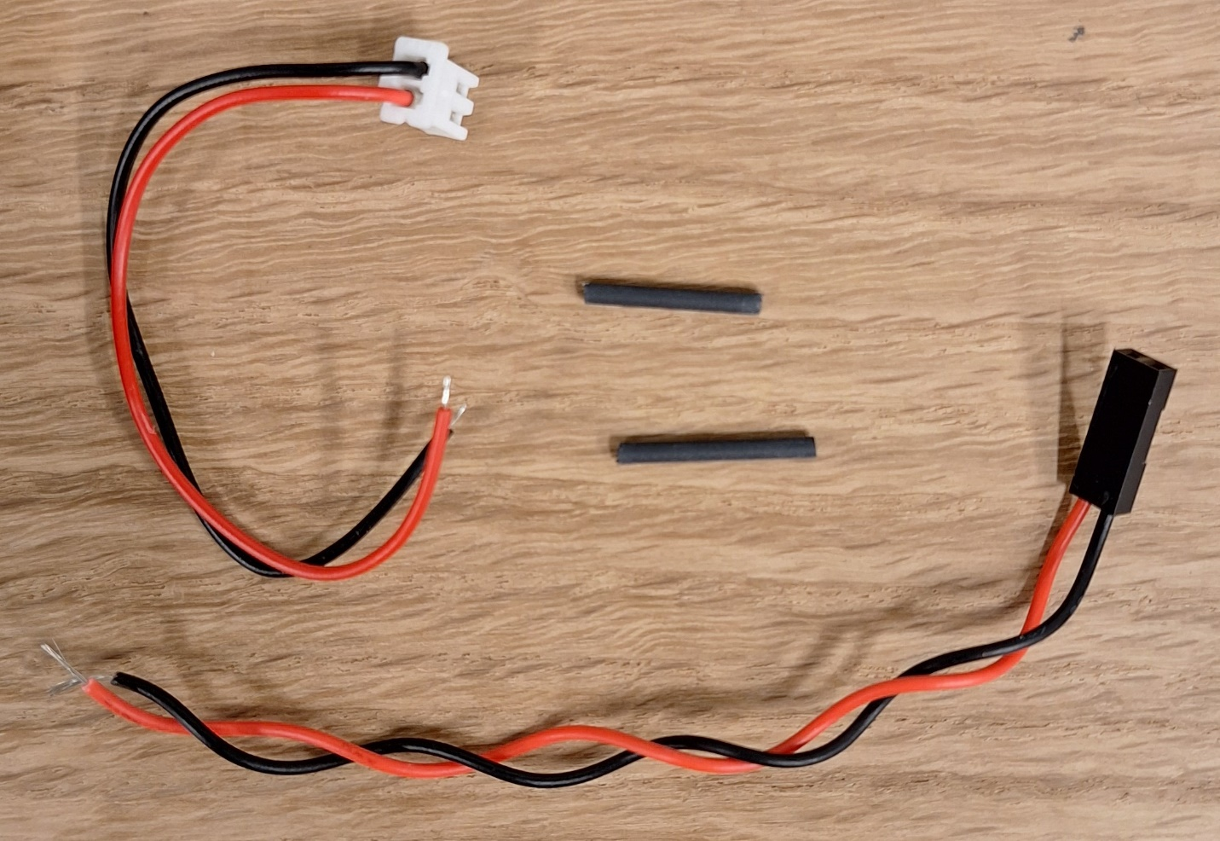

The elements of the cable which connect the output of the high voltage board to the DB25 relay control board in the diecast aluminum box.

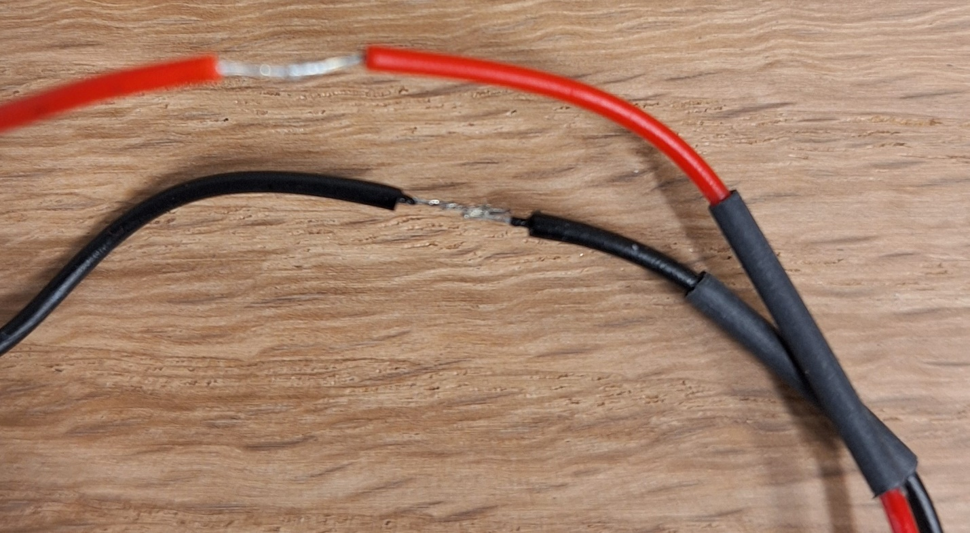

Solder the wires to each other as shown, being careful to put the heath shrink on one of the wires before making the solder joint.

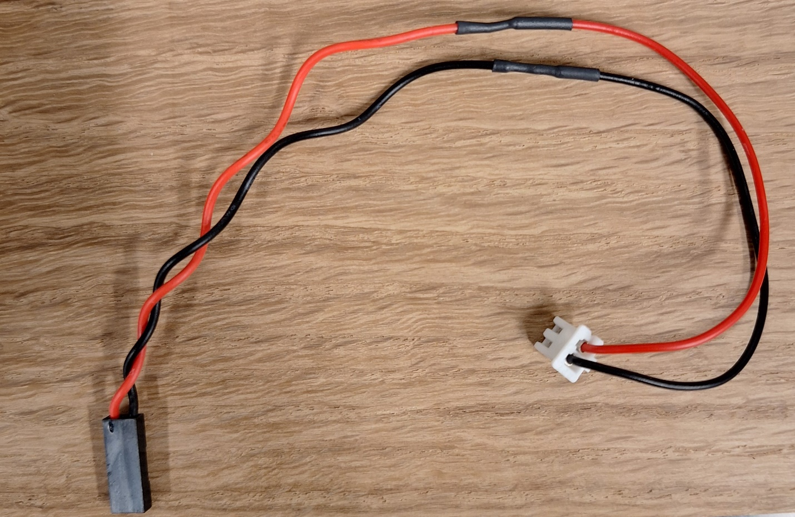

Fully assembled high voltage cable.

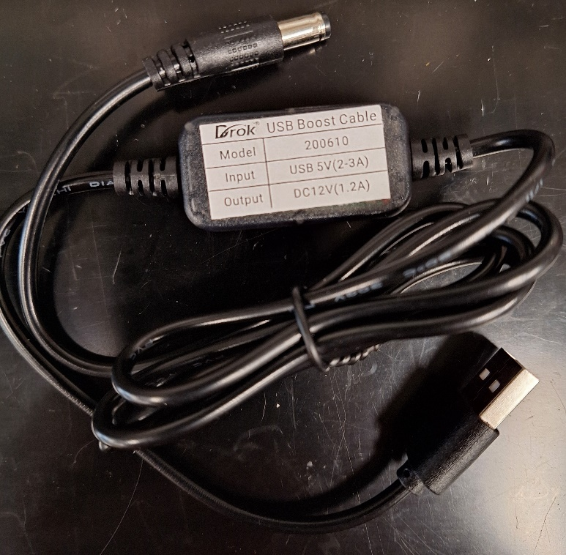

The Drok USB Boost Cable which converts 5 volts from the Arduino into 12 volts for the input of the high voltage boost board.

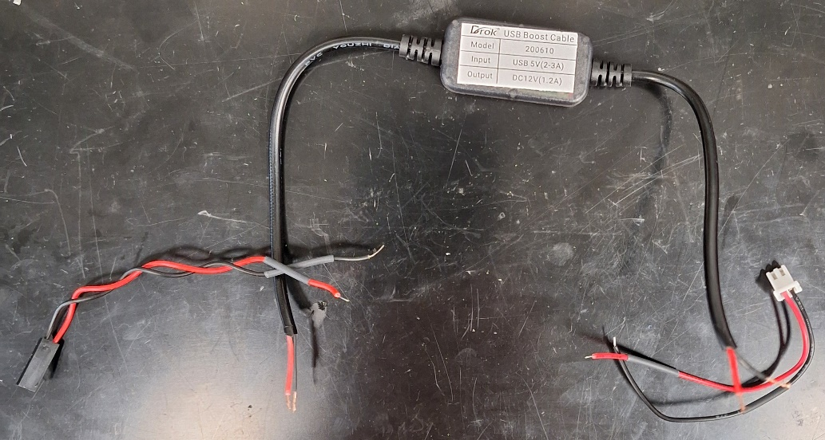

Cut off both ends of the boost unit, about 6 inches in. Note which side is the 5 volts in! The input is on the left when the label is right side up, at least in the units we have examined so far. Check that your is the same before cutting off the connectors, so you know for sure which is input and which is output. The input will have half of the cable we cut in half in the beginning of this build, and the output will be the input cable to the high voltage board.

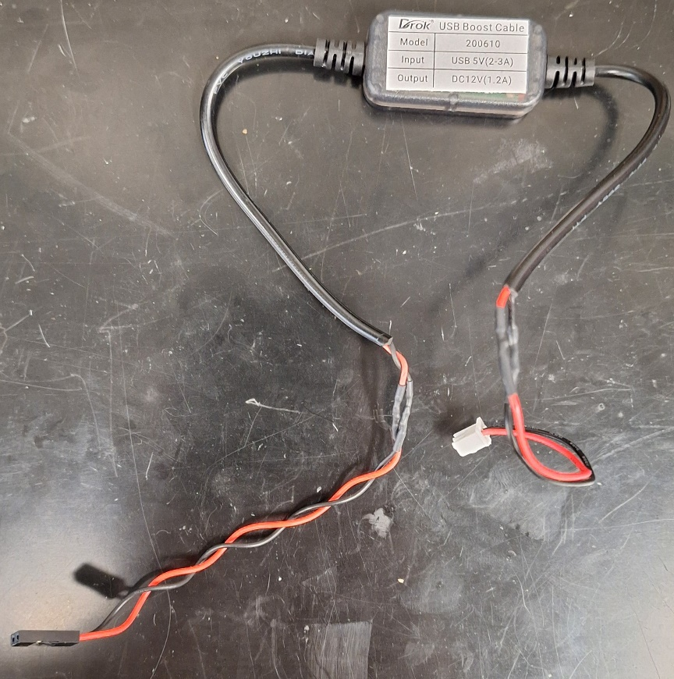

Put heat shrink on wires, solder them all up, and then slide heat shrink over the solder joint and shrink it with a heat gun, being careful not to dump so much heat in that you melt the solder.

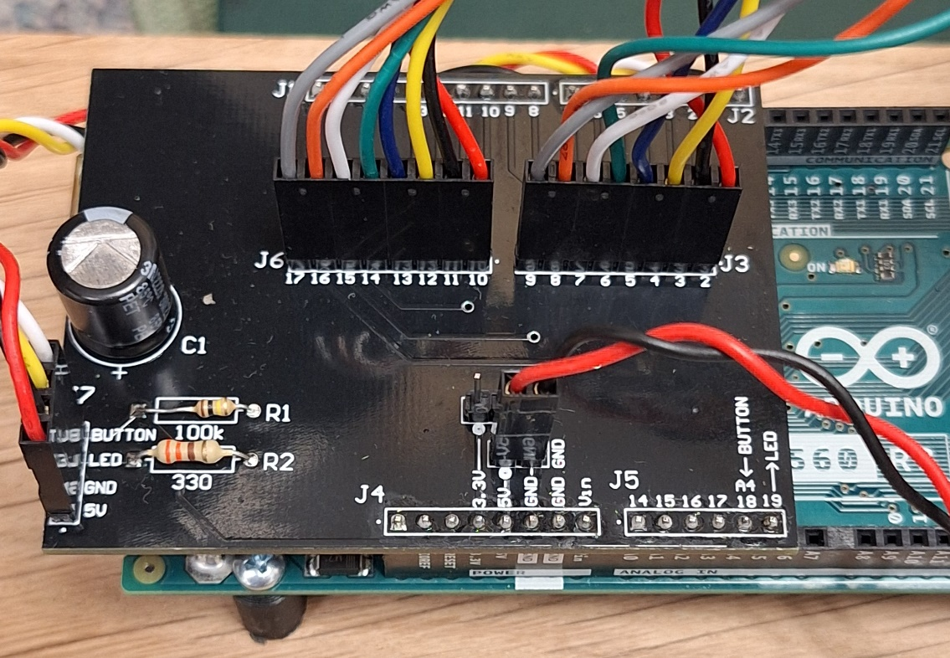

Plug in the 5 volts, then plug the Arduno UNO into a USB power supply or computer.

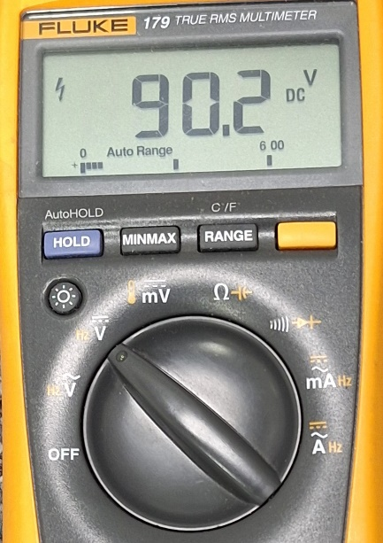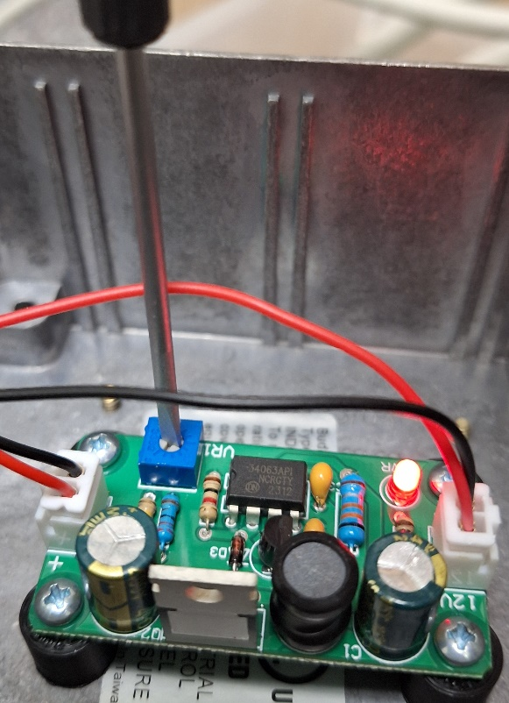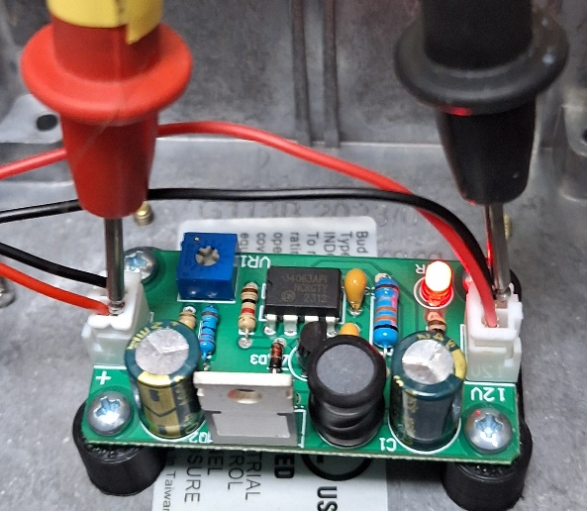

Assemble the full system from the 5 volt input which goes to the Arduino UNO input to the final output which goes to the DB25 relay control board. Use the probes of a volt meter very carefully to measure the voltage as shown, being careful to keep the probes far enough away from each other that they can’t cause the high voltage to arc. Turn the screw until the voltage is close to 90 volts.